**Tactile Navigation support for Blind Individuals**

HariChandana Bethapudi,1, a) Joshika Masineni,Arshia Parveen Heerapur, Hemanth Reddy Kaluva, Akshaya Gundagala2,3,4 ,5b)

*1Associate Professor, Computer Science and Engineering, Srinivasa Ramanujan Institute of Technology, Anantapur, India.*

*2,3,4,5 Computer Science and Engineering, Srinivasa Ramanujan Institute of Technology*

*a)*[*harichandana.cse@srit.ac.in*](mailto:harichandana.cse@srit.ac.in)

*b)*[*204g1a0545@srit.ac.in*](mailto:204g1a0545@srit.ac.in)

*c)*[*204g1a0515@srit.ac.in*](mailto:204g1a0515@srit.ac.in)

*d)*[*214g5a0506@srit.ac.in*](mailto:214g5a0506@srit.ac.in)

*e)*[*214g5a0501@srit.ac.in*](mailto:214g5a0501@srit.ac.in )

**Abstract.** Sighted individuals possess the ability to navigate their surroundings with ease and utilize their visual facility to promptly identify potential hazards. Conversely, individuals who are visually impaired are unable to perceive the external environment, traverse independently, or discern danger. Moreover, they may occasionally feel distressed and wish to notify their family or friends of their location via text. So, the primary challenge faced by visually impaired individuals is their reliance on others, as even their closest relatives may not always be able to provide adequate care. To address this issue, "Smart Stick" would be developed utilizing the "Internet of Things". Using a variety of sensors, including ultrasonic, soil moisture, RF, GPS, and GSM modules and using Arduino UNO, the Smart Stick empowers blind people to be self-adequate and gives them sense of normalcy.

**Keywords: Smart Stick, Ultrasonic Sensor, Soil Moisture, Solar Panel, Infrared Sensor, GPS-GMS Module, Relay Module, RF Module, User setup Notification.**

# INTRODUCTION

Individuals who are visually impaired have several challenges in their daily lives, including those related to social interaction, movement, and information retrieval. Their freedom and quality of life may be impacted by these challenges. The World Health Organization estimates that 285 million individuals worldwide suffer from vision impairment. Of them, 39 million are thought to be blind, and 246 million have impaired vision. Over 80% of vision impairment worldwide is thought to be curable or preventable. Those with vision impairments find it difficult to navigate since they are unable to recognize potential dangers or obstacles. Their capacity to engage in daily tasks may be restricted and traveling outside the home may become difficult as a result. Furthermore, information access may be challenging for those who are visually challenged, especially if the material is presented in a visual style. It may also be more difficult for them to interact with the outside world and to read books, newspapers, or signs as a result.

The need for assistive technologies that might make it easier and more independent for visually impaired people to navigate the world is critical given the difficulties they experience. One such piece of technology that could make a positive impact on the lives of visually impaired people is the Smart stick, which offers improved information access, mobility, and navigation.

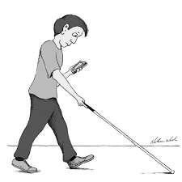

**FIGURE 1: Blind People**

**LITERATURE SURVEY**

The literature review section provides an overview of prior research and findings related to wet/damp surfaces, object detection, upstairs detection, and the Internet of Things (IoT). This survey seeks to contextualize the state of the field as it is today to close knowledge gaps and establish the foundation for the recommended technique.

*Development of a walking assistance using Ultrasonic sensor*

This paper describes the creation of an ultrasonic walking stick obstacle detection for those with vision impairments. The central processing unit (CPU) of the system is a PIC microcontroller, which sounds a buzzer to warn the visually impaired user to impediments that are identified within a 5 to 35 cm range [1]. Although the technology makes it easier to navigate safely in a variety of locations, it has trouble recognizing some barriers, such stairs and wet surfaces [5]. The study emphasizes the usefulness of the suggested walking stick while pointing out areas that might be improved in subsequent iterations to solve its present shortcomings.

*Exploring Visionary Walking Aids: Focus on Water Surface Detection*

A unique walking assistance system for the visually handicapped is presented in this study. It combines a voice module, an ultrasonic sensor, soil moisture sensor, object, and water sensors, and a blind stick framework [2]. The Arduino UNO receives input from the ultrasonic sensor about obstacles and processes it. The Arduino UNO calculates the obstacle's proximity after analyzing the data. Nothing is done if there is not a barrier to the circuit closing [6]. Most notably, when obstacles are detected within 50 cm of the device, a single voice alert is generated by the system. The study focuses on the technology design and operation of the developed walking aid device for visually impaired individuals [7].

*GPS-Based Stick Localization: Challenges and Constraints*

To pinpoint an object's accurate ground position smart stick, to be exact, this paper describes the use of the GPS as a satellite navigation system [3]. The stick's location data is updated to a central main board through this system. It is crucial to remember, nevertheless, that this system's effectiveness is limited indoors because GPS signals are unavailable there [4]. Additionally, signals are only precise within 5-meter range, indicating limits in the technology. Under some operational scenarios, the study emphasizes the intrinsic limitations of GPS-based positioning systems [8].

*RF-Based Stick Localization for Visually Impaired Autonomy*

If the stick is misplaced from its intended location, visually challenged people can be informed of its whereabouts by activating RF remote control device. The remote control may send signals to the stick thanks to the RF modules, which enable wireless communication [10]. By providing a concrete method of directing visually impaired individuals back to the proper location of the stick, this communication increases their independence and reduces the possibility of misplacing [9]. To create a dependable and effective localization system for assistive sticks intended for people with vision impairments, RF technology must be integrated.

# OBJECTIVE

The main objective is to develop a comprehensive model geared towards enabling autonomous navigation for individuals with visual impairment in diverse environments, encompassing both familiar and unfamiliar locales. The implementation includes an alert system utilizing a buzzer to effectively signal the presence of obstacles, facilitating obstacle detection and avoidance. Additionally, the work focuses on the creation of a user-friendly interface featuring tactile feedback and discernible sensations specifically tailored for blind users. The intent is to provide a nuanced and accessible interface, allowing blind individuals to interpret environmental cues and navigate with enhanced self-sufficiency.

# PROPOSED SYSTEM

# The proposed system is capable of detecting the surroundings for various barriers of different sizes and producing the required auditory using the ultrasonic sensor in the presence of buzzer. When damp surfaces are detected using sensors, it might alert the user by vibratory sounds and also enable to send SMS based on the user's location in an emergency or when they are having trouble. When the stick is misplaced, the user can find the stick by using RF remote control.

# Block diagram

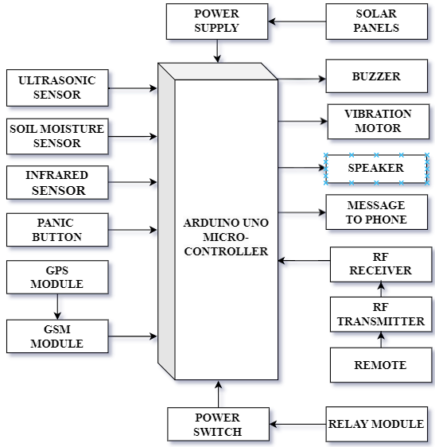

**FIGURE 2: Block Diagram of Smart Stick**

# METHODOLOGY

# Developing a Smart stick comprising three modules: one for Object Detection & Wet surface Detection alerts the user by sending buzzer & vibration sounds, second for GMS and GPS Modules for sending location to mobile devices via Push button and another is for the remote control, which is utilized to locate a misplaced stick by sounding an alert.

*Module 1: Object and Wet Surface Detection*

The first module utilizes ultrasonic for object detection and soil moisture for wet surface. Alerts the user through a dual-alert mechanism, comprising a buzzer for auditory signals and a vibration mechanism for tactile feedback.

*Module 2: GSM and GPS Location Notification System*

The second module incorporates GPS and GSM modules for accurate communication and position tracking. Actual-time location notifications are transmitted via push notifications to pre-specified mobile devices when user-initiated push button is pressed. Combines location-based communication with sophisticated environmental awareness to create absolute Smart Stick solution.

*Module 3: Remote Control*

The third module designed with an RF module and a dedicated remote control unit, this module introduces remote control capabilities for locating the stick. Users can remotely activate location alerts, adding a layer of convenience to the Smart Stick. Auditory feedback through a buzzer enhances the user experience during remote control interactions, making the system more user-friendly and accessible.

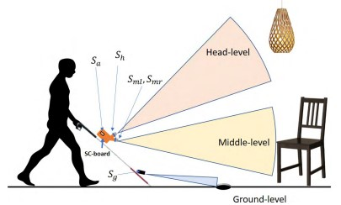

**FIGURE 3: Sketch of obstacles**

# Components

# *5.1.1. Arduino UNO*

The ATmega328P microprocessor is included on the Arduino UNO microcontroller board. This encompasses 14 digital i/o pins, with six configurable as PWM pins, and 6 analog pins. The board is equipped with 16 MHz resonator made of ceramic, an USB link for computer interfacing, ICSP header for a reset button and on-board programming. This provides comprehensive support for the microcontroller, facilitating ease of use by utilizing an AC-to-DC adapter to supply power to it or a USB connection to a computer.

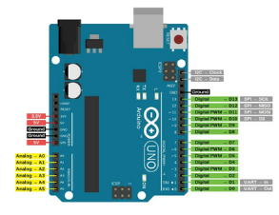

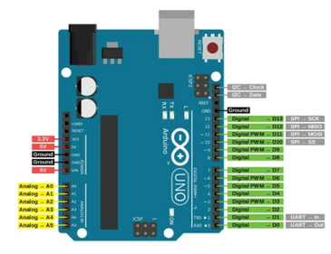

**FIGURE 4: Arduino UNO**

# *5.1.2. Ultrasonic Sensor*

Target distance is measured by the electrical transducer in the ultrasonic sensor. by emitting ultrasonic waves. Utilizing piezoelectric crystals, the transmitter releases sound waves, which, upon reflecting off the target, are captured by the receiver. The received signals are then converted into electrical signals, enabling precise distance measurement. Notably, ultrasonic waves operate beyond the audible range of humans, with the sensor's core components are being the transmitter and receiver.

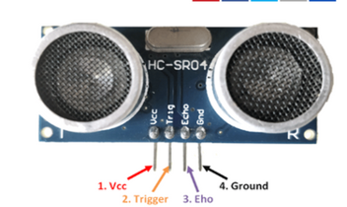

**FIGURE 5: Ultrasonic Sensor**

# *5.1.3. Soil Moisture*

The soil moisture sensor functions as a device designed to quantify the amount of water in the soil by volume. Unlike conventional approach that involves the removal, drying, and weighing of soil samples, these sensors employ alternative methodologies. Measurement of volumetric water content is achieved indirectly, utilizing parameters such as dielectric constant, electrical resistance, or interactions with neutrons. These sensors rely on principles other than direct gravimetric measurements, providing more efficient and non-invasive means of assessing soil moisture content.

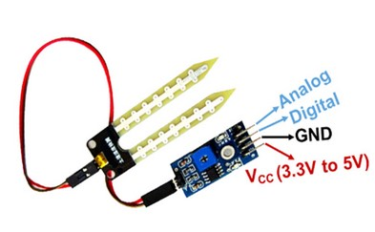

**FIGURE 6: Soil Moisture Sensor**

# *5.1.4. Infrared Sensor*

An electronic gadget that recognizes infrared radiation is called an infrared sensor, including movement and object heat. Operating as a sensitive photodiode in the non-visible spectrum, it undergoes resistance and voltage changes proportional to received infrared light intensity. Widely used for object presence detection, it is effective in identifying objects within a specified area.

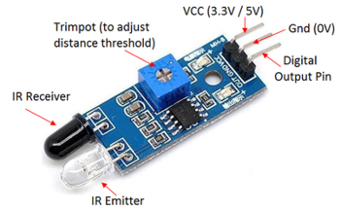

**FIGURE 7: Infrared Sensor**

# *5.1.5. RF Module*

An RF module is a small technological gadget that makes wireless communication between two devices through the transmission and reception of radio signals. This wireless exchange of information can be achieved via use of optical transmission. Widely used in embedded systems, RF modules play a crucial role in establishing efficient wireless connectivity, utilizing either optical or radio-frequency communication methods.

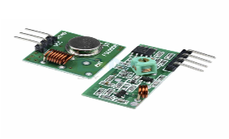

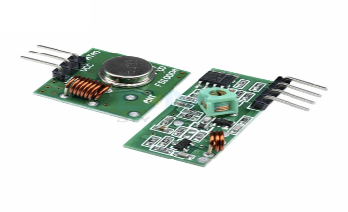

**FIGURE 8: RF Module**

# *5.1.6. GSM Module*

The GSM module is integral for device communication with the GSM network, managing the establishment and upkeep of communication links. It plays a key role in emergency notifications, alerting designated recipients via SMS. Operational prerequisites include integration with a cellular network and SIM card.

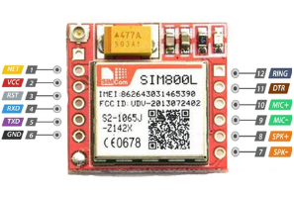

**FIGURE 9: GSM Module**

# *5.1.7. GPS Module*

GPS is a satellite-based navigation system delivering time and location data to GPS receivers. It operates in all weather conditions and is utilized to provide accurate location information, including latitude, longitude, altitude, and time, to devices like Arduino Uno via serial communication. It is instrumental in assisting visually impaired individuals by sharing precise location details with distressed parties.

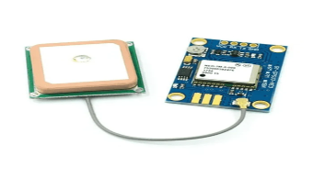

**FIGURE 10: GPS Module**

# *5.1.8. Relay Module*

Relay modules are electromagnet-operated electrical switches that are triggered by low-power signals from microcontrollers. It controls electrical circuits by opening or closing, comprising a coil, solenoid, iron yoke, movable armature, and contacts.

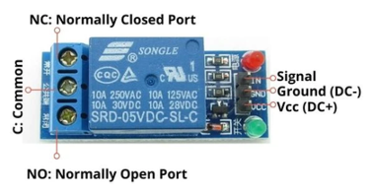

**FIGURE 11: Relay Module**

# *5.1.9. Battery*

An energy-storage device that transforms chemical energy into electrical energy is a battery. through electrochemical reactions. It consists of cells with three primary components: an anode ('-'), a cathode ('+'), and an electrolyte facilitating chemical reactions. Batteries serve as essential power sources in diverse applications, functioning by harnessing chemical potential energy and transforming it into electrical energy for utilization in electronic systems. The controller receives its power from a 12 V Li-ion battery that is reusable, which supplies necessary power to all of the sensors and modules that are linked to it.

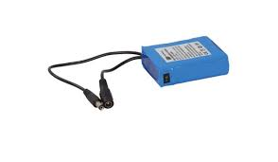

**FIGURE 12: Battery**

# *5.1.10. Speaker*

A speaker is employed as an auditory signaling component to deliver audio alerts to the user. The relay associated with the infrared sensor is configured to trigger upon detecting an obstruction, subsequently activating the speaker to emit alerting sound. This relay-driven mechanism ensures that the speaker is engaged in response to the infrared sensor's detection of an obstacle, providing effective means of alerting the user to the presence of obstructions in the monitored environment.

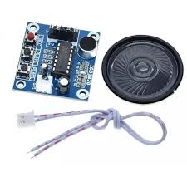

**FIGURE 13: Speaker**

# *5.1.11. Vibration Motor*

A vibratory motor, is deliberately unbalanced three-phase motor used for vibrating sieves and providing haptic feedback. Controlled by a relay triggered by a moisture sensor detecting water, the motor is activated to induce vibration in response to the detected moisture presence. The relay linked to the moisture sensor is then activated, facilitating the seamless integration of the vibratory motor into the system.

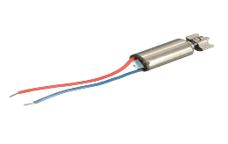

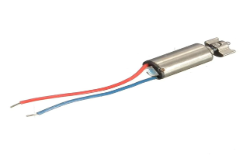

**FIGURE 14: Vibration Motor**

# *5.1.12. Solar Panels*

A solar panel, utilizing photovoltaic cells, converts sunlight into electricity by exciting electrons. These electrons generate direct current (DC) electricity, suitable for powering devices or storing in batteries. The setup incorporates two 4V solar panels for a battery charging alongside a conventional power source. Solar technologies, employing mirrors or PV panels, harness solar energy for electricity production or storage in thermal storage or batteries.

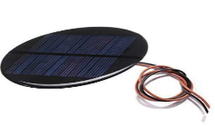

**FIGURE 15: Solar Panels**

# *5.1.13. Push Button*

When pressed, a push button can transmit the user's position as a communication with the relevant contacts in the event of an emergency. It serves as an emergency and distress signal for the user.

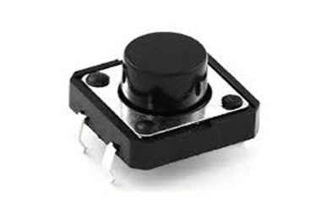

**FIGURE 16: Push Button**

# 5.1.14. Switch

In an electrical circuit, a switch is used to connect or detach the conducting channel, stopping the flow of current. In order to preserve battery life, it is utilized to switch the stick on or off while not in use.

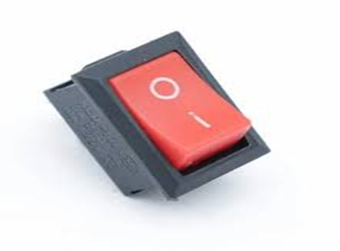

**FIGURE 17: Switch**

# 5.1.15. Adapter

An adapter is a device that changes the characteristics of one electrical system or device to another that would not otherwise work together. Power adapters change the voltage from AC to a single DC by plugging them into a wall outlet.

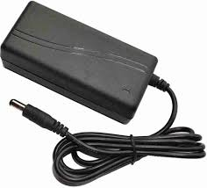

**FIGURE 18: Adapter**

**IMPLEMENTATION**

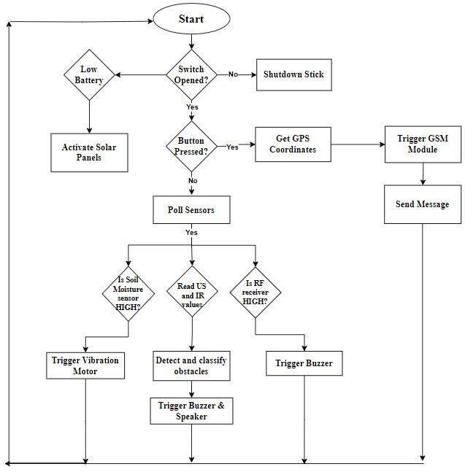

**FIGURE 19: Implementation of Proposed system**

*Switch*

The smart blind stick activates and becomes operational when the switch is turned on. It does not begin to operate if it is not turned on.

*If switch == 1 -- Smart Blind Stick On (1)*

*Else -- Smart Blind Stick Off*

*Objects Detection*

It is positioned two thirds of the way up the stick's length away from the bottom end in order to detect impediments. This configuration can identify barriers of different sizes and shapes. Following the analysis of the data from these sensors, the logic in the "Table 1" below determines the type of obstacle, and the buzzer is used to play the appropriate answer to the user.

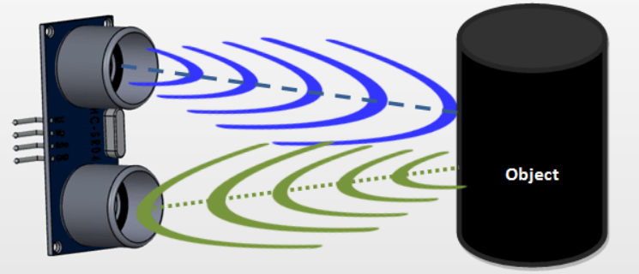

**FIGURE 20: Sensing the objects using Ultrasonic sensor**

*a = pulseIn(echoPin, HIGH); (2)*

*d=(a/2)/29.1; (3)*

*If d < 20*

*If (d > 50 && d < 100)*

*Alerts voice1*

*If d < 35*

*If d < 150*

*If (d > 150 && d < 200)*

*Alerts voice2*

*Else*

*No Alert*

*Where voice1 - Speaker*

*Voice2 - Buzzer*

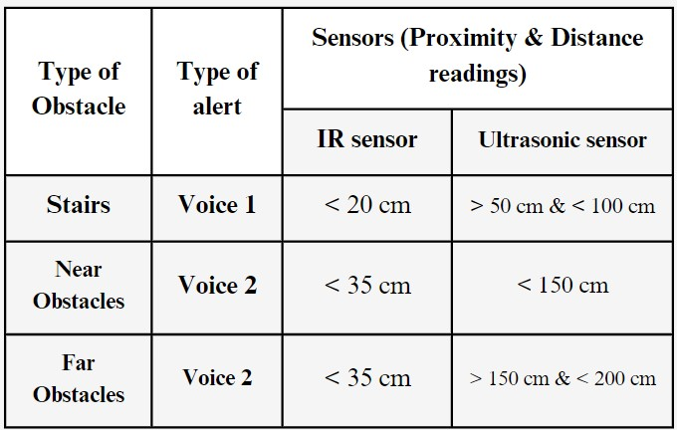

**TABLE 1: Classification of obstacles based on sensor readings**

An ultrasonic sensor positioned at a about 40° angle on the stick was used to detect the objects. In order to demonstrate that there are no objects in the road, the distance of the sensor shouldn’t be greater than 74 cm if it is positioned at a height of 56 cm.

One of these methods is sound, where a buzzer is utilized that stands out from the others by making a sound that blind people can identify—beeps.

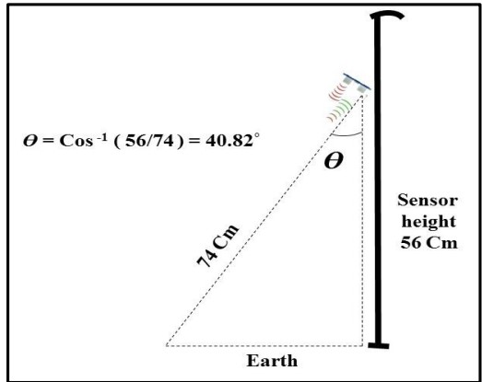

**FIGURE 21: Inclination of Ultrasonic sensor**

*Moisture Level*

When the moisture sensor reaches the threshold value, it operates by scanning the surface and providing a boolean output. The vibration motor, which is affixed to the top end of the stick, alerts the user by vibrating.

*If value > 50 -- Vibration Motor On (4)*

*Else -- Vibration Motor Off*

*IR sensor*

In order to facilitate the recognition of stairs and other tiny impediments on the ground, an The stick has infrared fitted at the bottom. Using a voice kit, we are able to verify that the speaker is issuing the proper speech warning and to examine the entire operation.

*If motion == 1 -- Speaker On (5)*

*Else -- Speaker Off*

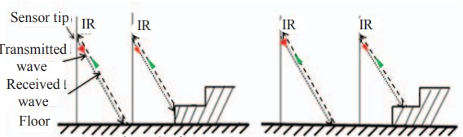

**FIGURE 22: IR sensor for Upstairs**

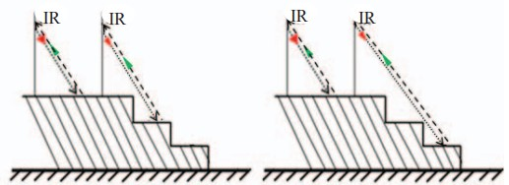

**FIGURE 23: IR sensor for Downstairs**

*RF Receiver*

An RF transmitter positioned on a basic remote controller sends an RF signal to an RF receiver mounted on a stick. Together with the RF transmitter, this remote controller also features a straightforward push button that, when depressed, sends out an RF signal that the blind stick's RF receiver picks up and helps the user find it by raising a buzzer alarm for a short while after getting the signal.

*If remote == 1 -- Find the position of stick (6)*

*Else Can’t find the position of stick*

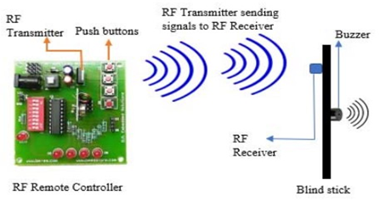

**FIGURE 24: RF Mechanism**

GPS & GSM

The GPS module polls the user for their coordinates when it detects a button press. The syntax for these coordinates is "http://maps.google.com/maps?q=loc:<latitude>,<longitude>," which is the URL for a Google Maps location. The link is then prefaced with a suitable phrase, like "Alert please help me," and this processed message is sent via the GSM module. to the user's caregivers.

*If pushbutton ==1 -- Activate the GPS Module (7)*

*If GPS == 1 -- Activate the GSM Module (8)*

*If GSM ==1 -- Send Location to coordinates (9)*

*Else – No Location sent*

*Else – No Activation of GSM Module*

*Else – No Activation of GPS Module*

**RESULT**

The Circuit diagram for the while setup of the Smart Stick. It is capable of detecting the surroundings for various barriers of different sizes and producing the required auditory using the ultrasonic sensor in the presence of buzzer. When damp surfaces are detected using sensors, it might alert the user by vibratory sounds and also enable to send SMS based on the user's location in an emergency or when they are having trouble. When the stick is misplaced, the user can find the stick by using RF remote control.

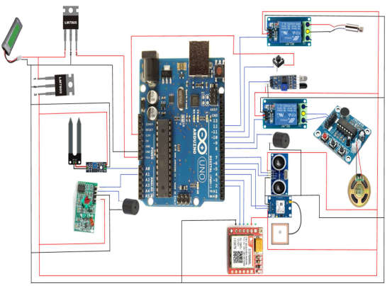

**FIGURE 25: Experimental Setup**

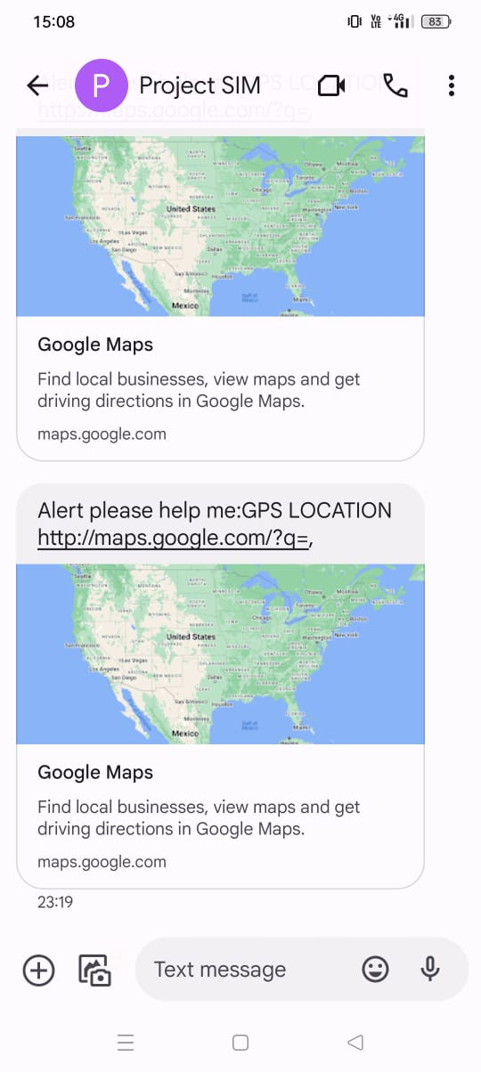 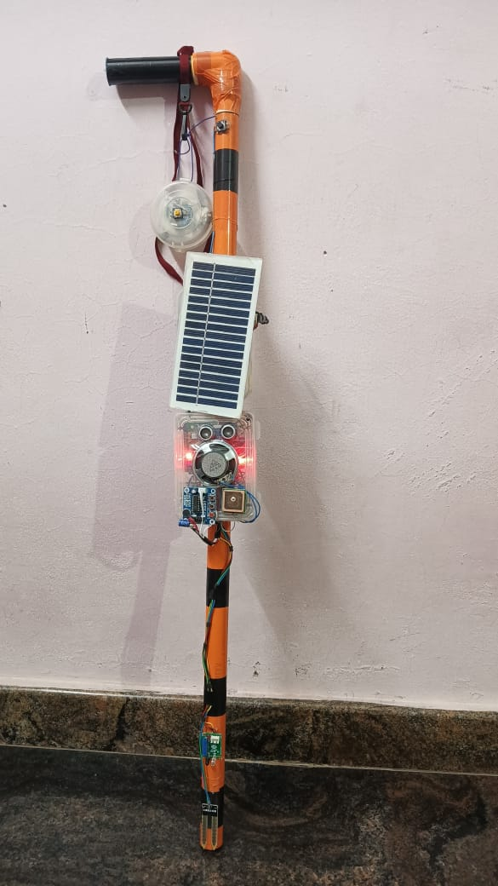

**FIGURE 26: Alert Messages to the Coordinates FIGURE 27: Smart Blind Stick**

**of the Blind Person**

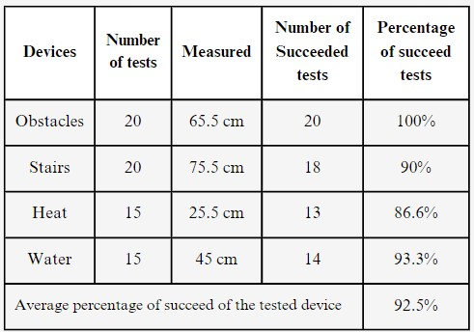 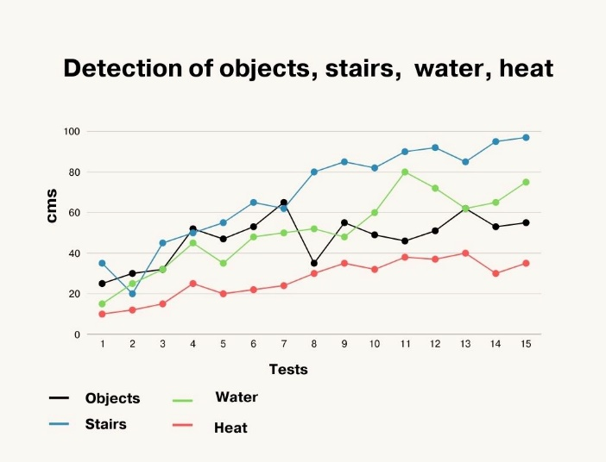

**TABLE 2: Tests of Smart Blind Stick FIGURE 28: Detection of Objects, stairs, water, heat**

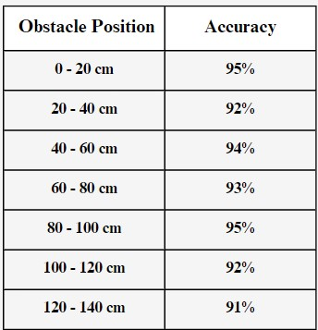 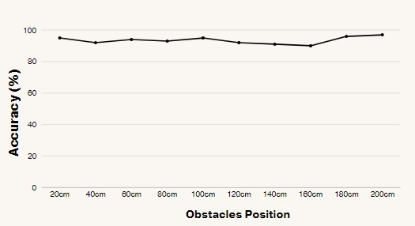

**TABLE 3: Reliability for obstacle position FIGURE 29: Reliability for obstacle position**

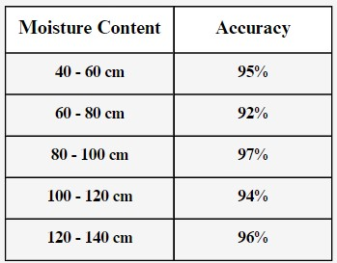 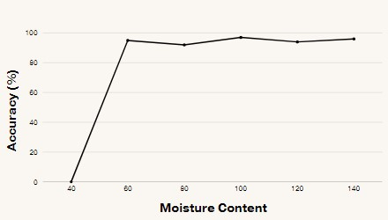

**TABLE 4: Reliability for moisture content FIGURE 30: Reliability for moisture content**

**CONCLUSION**

Finally, the proposed system effectively detects barriers using the ultrasonic sensor with auditory alerts and provides safety features such as vibratory alerts for damp surfaces and emergency SMS based on user location. The inclusion of an RF remote control for stick retrieval enhances user autonomy. The system offers a comprehensive solution for obstacle detection, emergency response, and stick location retrieval, making it valuable tool for individuals with visual impairment.

**FUTURE SCOPE**

The future scope for the multifunctional blind stick encompasses machine learning for adaptive obstacle detection, smart navigation for optimized routes, advanced communication with voice recognition, IoT connectivity, wearable technology exploration, user feedback mechanisms, improved indoor localization, adherence to global accessibility standards, community integration, and miniaturization for enhanced user adoption.

**REFERENCES**

**[1].** Naiwrita Dey, Ankita Paul, Pritha Ghosh, Chandrama Mukherjee, Rahul De,“[Ultrasonic Sensor Based Smart Blind Stick](mailto:Ultrasonic Sensor Based Smart Blind Stick)”, International Conference on Current Trends toward Converging Technologies, Coimbatore, India, 978-1-5386-3702-9/18 2018.

**[2].** Md.Adil, TaiyabaShadaka Rafa, Jannatul Ferdoush, Abir Mahmud, Abhijit Pathak, “[An IoT based Voice Controlled Blind Stick to Guide Blind People](mailto:An IoT based Voice Controlled Blind Stick to Guide Blind People)”, International Journal of Engineering Inventions, Volume 9, Issue 1 Jan 2020.

**[3].** Somnath koley, Ravi Mishra, “[Voice operated outdoor navigation system for visually impaired persons](mailto:Voice operated outdoor navigation system for visually impaired persons)”, International Journal of Engineering Trends and Technology- Volume 3, Issue2- 2012.

**[4].** Suraj Babhale, Pratiksha Bhagat, Nikhita Saharkar, Mayur Pillewan, Nikhil Rangari, V. N. Mahawadiwar, “[Implementation of Smart Stick for Blind and Visually Impaired People using Arduino](mailto:Implementation of Smart Stick for Blind and Visually Impaired People using Arduino)”, International Journal of Innovative Research in Science, Engineering and Technology, Volume 10, Issue 6, June 2021.

**[5].** M. Ghana Shyam, Shravankumar G M, Ashabee, Kodal Ashwini, Ravi Kumar H M, “[Blind guide stick using GPS and GSM module](mailto:Blind guide stick using GPS and GSM module)”, International Research Journal of Engineering and Technology Volume 7, Issue 6, June 2020.

**[6].** Ronak Panchal, Sneha Sankhe, Saad Khan, Vishal Singh, “[Blind Stick for Visually Impaired People](mailto:Blind Stick for Visually Impaired People)”, International Research Journal of Engineering and Technology Volume 8,Issue 5, May 2021.

**[7].** Mohd Helmy Abd Wahab, Amirul A. Talib, Herdawatie A. Kadir, Ayob Johari, A.Noraziah, Roslina M. Sidek, Ariffin A. Mutalib, “[Smart Cane: Assistive Cane for Visually-impaired People](mailto:Smart Cane: Assistive Cane for Visually-impaired People)”, International Journal of Computer Science Issues, Vol. 8, July 2011.

**[8].** R.Dhanuja, F.Farhana, G.Savitham “[Smart Blind Stick Using Arduino](mailto:Smart Blind Stick Using Arduino)”, International Research Journal of Engineering and Technology, Volume 5, Issue 3, March 2018.

**[9].** Mukesh Prasad Agrawal, Atma Ram Gupta, “[Smart Stick for the Blind and Visually Impaired People](mailto:Smart Stick for the Blind and Visually Impaired People)”, Proceedings of the 2nd International Conference on Inventive Communication and Computational Technologies (ICICCT 2018) IEEE Xplore Compliant - Part Number: CFP18BAC-ART; ISBN:978-1-5386-1974-2.

**[10].** Deepasri. S, Prof. Sujatha. S, “[Real Time Object Detection and Voice Assistance for Blind Using Tensorflow](mailto:Real Time Object Detection and Voice Assistance for Blind Using Tensorflow)”, International Journal of Research Publication and Reviews, Vol 3, no 9, pp 52-55, September 2022.

**[11].** Ankit Agarwal, Deepak Kumar, Abhishek Bhardwaj, “[Ultrasonic Stick for Blind](mailto:Ultrasonic Stick for Blind)”, International Journal Of Engineering And Computer Science ISSN:2319-7242 Volume 4 Issue 4 April 2015.

**[12].** Mohammed Azher Therib, “[Smart Blinding Stick with Holes,Obstacles and Ponds Detector Based on Microcontroller](mailto:Smart Blinding Stick with Holes,Obstacles and Ponds Detector Based on Microcontroller)”, Journal of Babylon University/Engineering Sciences/ No.(5)/ Vol.(25): 2017.

**[13].** Ayat A. Nada, Mahmoud A. Fakhr, “[Assistive Infrared Sensor Based Smart Stick for Blind People](mailto:Assistive Infrared Sensor Based Smart Stick for Blind People)”, Science and Information Conference 2015 July 28-30, 2015.

**[14].** Chaitra Mahantesh Lokannavar, Kavya CK, Kavya SM, Priya G R, Vijayananda V Madlur, “[Iot Based Navigation System For Visually Impaired People](mailto:Iot Based Navigation System For Visually Impaired People)”, Volume:05, Issue:05, May-2023.

**[15].** Suraj Babhale, Pratiksha Bhagat, Nikhita Saharkar, Mayur Pillewan, Nikhil Rangari, V. N. Mahawadiwar, “[Implementation of Smart Stick for Blind and Visually Impaired People using Arduino](mailto:Implementation of Smart Stick for Blind and Visually Impaired People using Arduino)”, International Journal of Innovative Research in Science, Engineering and Technology, Volume 10, Issue 6, June 2021.